# 20220918-Describing Change: History

## Notes

|  |  |  |  |  |
| --- | --- | --- | --- | --- |
| Pulling your leg  Make join |  | | | I was just pulling your leg.  拖后腿 |
| Weighing **Scales**  Balance | /skeɪlz/ | | | 天平 |
| Agriculture | /ˈæɡrɪkʌltʃə(r)/ | | | A large-scale farming enterprise;  the practice of cultivating the land or raising stock |
| Vase  cruse | /vɑːz/ | | | 花瓶 |
| Religion belief  Freedom of religion | /rɪˈlɪdʒən/ | | | a strong belief in a supernatural power or powers that control human destiny |
| Free masons |  | | | 同济会 |
| Sewer system  Sewer pipe | ˈsuːə(r); | | | a waste pipe that carries away sewage or surface water;  Sanitary sewer  Branch sewer |
|  |  | | |  |
| To transition  Transition period  Switch  changing | | /trænˈzɪʃ(ə)n/ | the act of passing from one state or place to the next; a change from one place or state or subject or stage to another | |
| Agricultural revolution | | /ˌrevəˈluːʃn/ | a drastic and far-reaching change in ways of thinking and behaving | |
| Hunting and gathering | | /ˈhʌntɪŋ/ |  | |
| **Settlement**  village | | /ˈset(ə)lmənt/ | a community of people smaller than a town;   conclusive resolution of a matter and disposition of it 协议 | |
| instance | | /ˈɪnstəns/ |  | |
| Iraq | | /ɪˈræk/ |  | |
| Domesticated  Food and animal | | /dəˈmestɪkeɪtɪd/ | Accustomed to home life | |
| Primary food supply  main | | /ˈpraɪməri/ |  | |
| Pottery 陶器  vase | | /ˈpɒtəri/ | the craft of making earthenware | |
| Form  To form | |  | the phonological or orthographic sound or appearance of a word that can be used to describe or identify something | |

## lesson

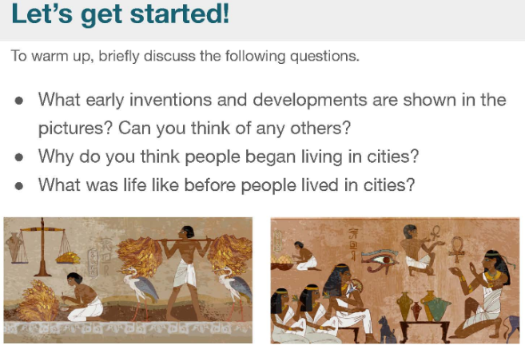

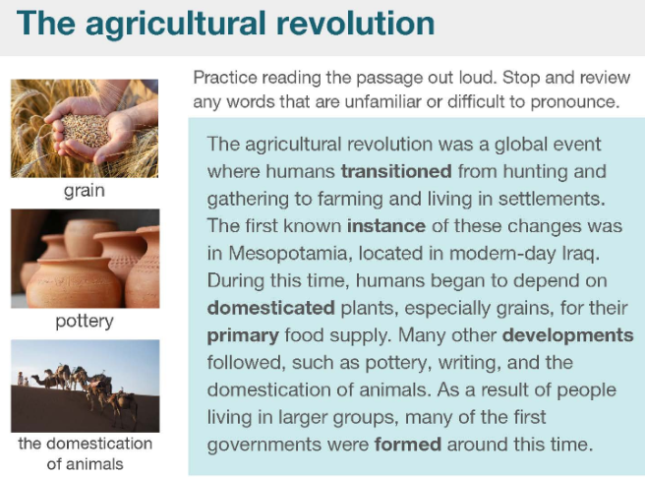

|  |  |  |
| --- | --- | --- |
| To transition  Transition period  Switch  changing | /trænˈzɪʃ(ə)n/ | the act of passing from one state or place to the next; a change from one place or state or subject or stage to another |
| Agricultural revolution | /ˌrevəˈluːʃn/ | a drastic and far-reaching change in ways of thinking and behaving |
| Hunting and gathering | /ˈhʌntɪŋ/ |  |
| **Settlement**  village | /ˈset(ə)lmənt/ | a community of people smaller than a town;   conclusive resolution of a matter and disposition of it 协议 |
| instance | /ˈɪnstəns/ |  |
| Iraq | /ɪˈræk/ |  |
| Domesticated  Food and animal | /dəˈmestɪkeɪtɪd/ | Accustomed to home life |
| Primary food supply  main | /ˈpraɪməri/ |  |
| Pottery 陶器  vase | /ˈpɒtəri/ | the craft of making earthenware |
| Form  To form |  | the phonological or orthographic sound or appearance of a word that can be used to describe or identify something |

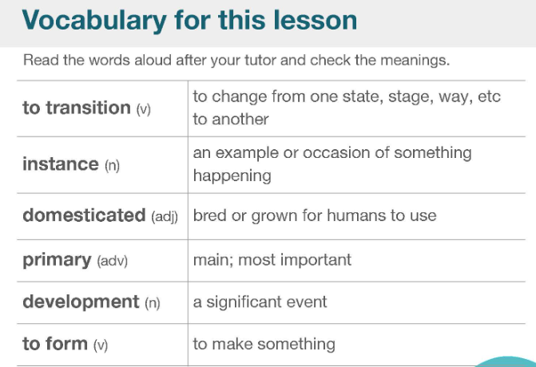 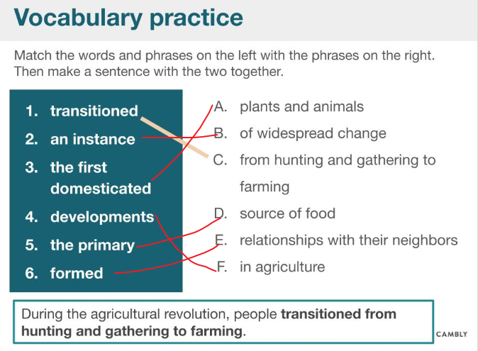 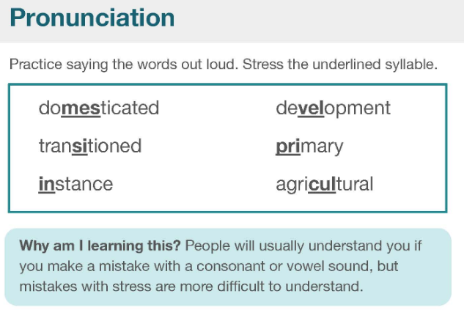 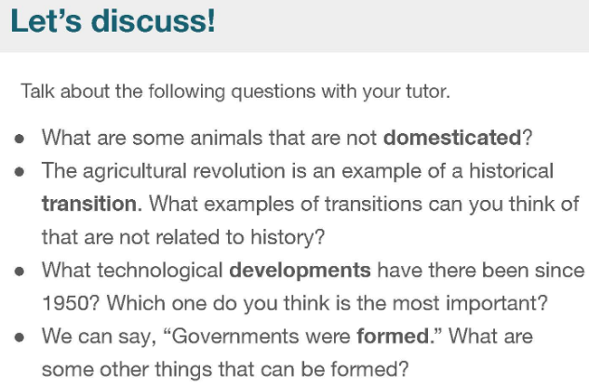 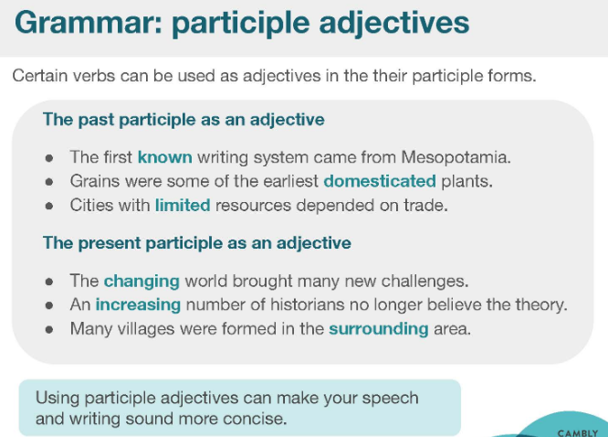 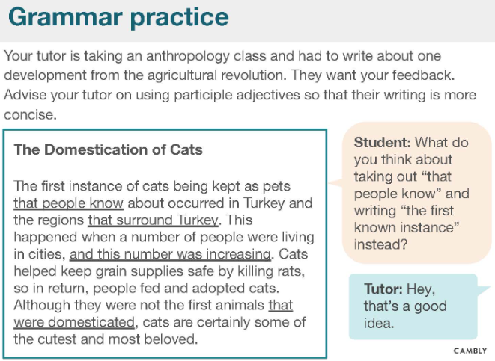 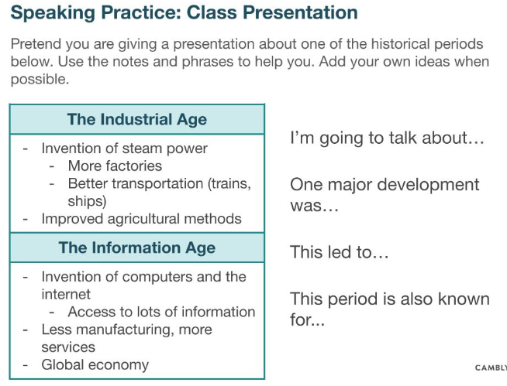

# 202209-22 Data, Charts, & Numbers: Business

<https://www.cambly.com/en/student/courses/5fa1de81b728c84f4ccaaa2f/60f1fc5e873ad0c4361bc569>

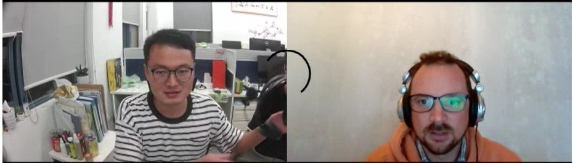

## Notes

|  |  |  |
| --- | --- | --- |
| Shift work |  |  |
| Stricter  limit |  | Stricter inspection  She is stricter with kids |
| The most/ the large/ the biggest is … followed by…  then followed by…,then we have…,  Lastly is | | |
| Effective factor |  | Population |
| GDP | Gross domestic product |  |
| Disposable income  Disposable income | /dɪˈspəʊzəb(ə)l/ | 可支配收入 |
| Shipping costs from origin to destination | /ˈʃɪpɪŋ/ | 运费 |
| Manufactured  Produced  made | /ˌmænjuˈfæktʃəd/ | Produced in a large-scale industrial operation;  Manufactured product;  Manufactured goods |
| Fake trainers | /feɪk/ | Fake fans |
| Would you be willing to assist me with my research? |  |  |
| Open the new store | location  Many things for sale  lower prices than competitors  reputation for selling good/reliable products | |
| chain store  McDonald's, KFC  starbucks |  |  |
| etc  etcetera  and so on;  and so forth | /ˌet ˈsetərə;/ | Et-ce-te-ra  More of the same;  additional unspecified odds and ends; more of the same |
| 11,500 | eleven thousand and five hundred;  eleven thousand, comma, 500 |  |
| one dollar  two dollars  ten dollars |  |  |
| midday  11pm - 12 am  11 am - 12pm |  | |
| The number of customers is highest in the afternoon. | From my point of view..... |  |
| The company value of Amazon is 4 times greater than that of Walmart.  ...but by 2015 the value of Amazon surpassed Walmart. | | |
| food chains  supply chain | /tʃeɪnz/ | a series of things depending on each other as if linked together |
| buy in bulk | bʌlk | Bulk cargo 散装 |

From different viewpoint, we get the different concluding.

From the graph, we get directly get the occupy of **

From the population, we know the biggest consumer market is China

|  |  |  |  |  |
| --- | --- | --- | --- | --- |
| Approximately  Around  almost | /əˈprɒksɪmətli/ | | Approxi-mately  Is approximately equal to;  Close in value but not exactly | |
| To estimate | /ˈestɪmət/ | | To use information to guess a number, amount, size | |
| overall |  | | Including everything | |
| Range |  | | A group of different things that are related;  A series of numbers, starting with the minimum and ending with the maximum | |
| distribution |  | | The act of delivering or giving a product to people | |
| whereas |  | | While, although | |
| 11,500 | 11 thousand, comma, 500  11 thousand and 5 hundred | |  | |
| 12,300 | 12 thousand, comma, 300  12 thousand and 5 hundred | |  | |
| Surpass  Overcome  Exceed  More than  Greater, bigger | | /səˈpɑːs/  Surpass the advanced | | be or do something to a greater degree  **her performance surpasses that of any other student I know** |
| Air conditioner | |  | |  |

## lesson

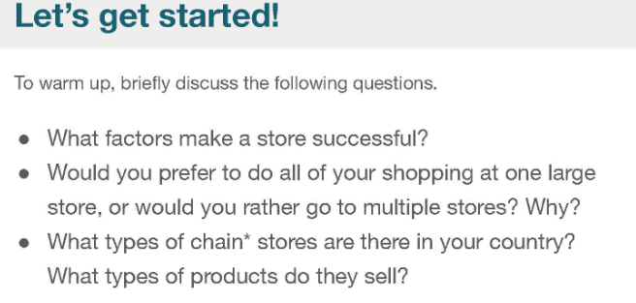

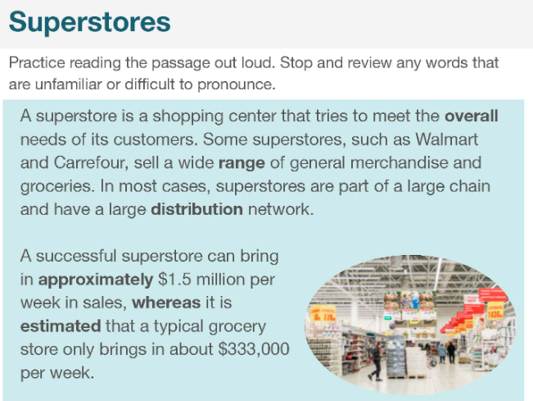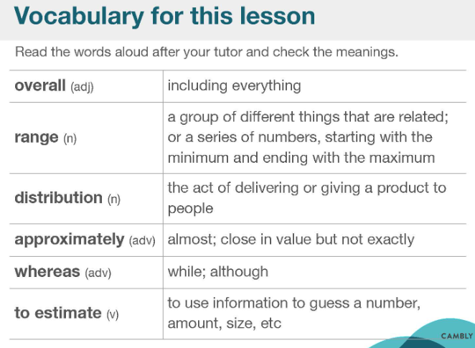

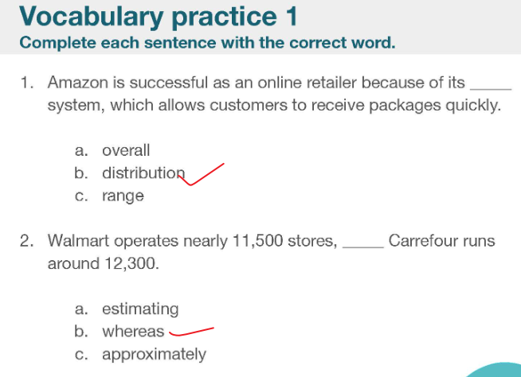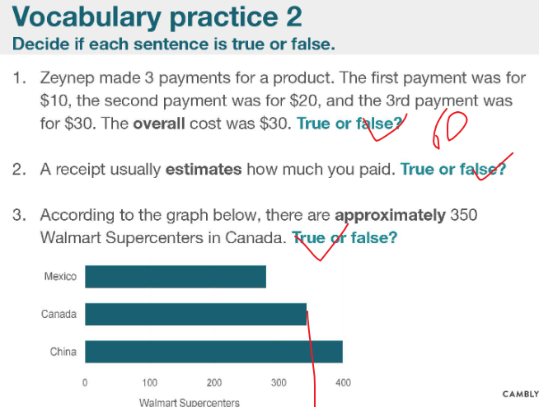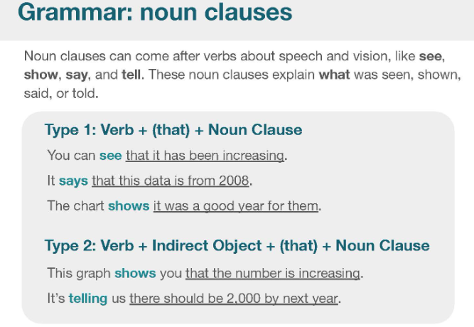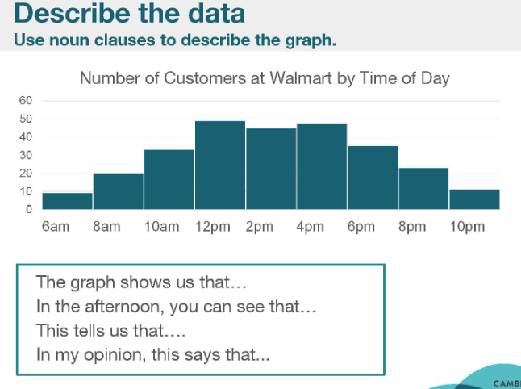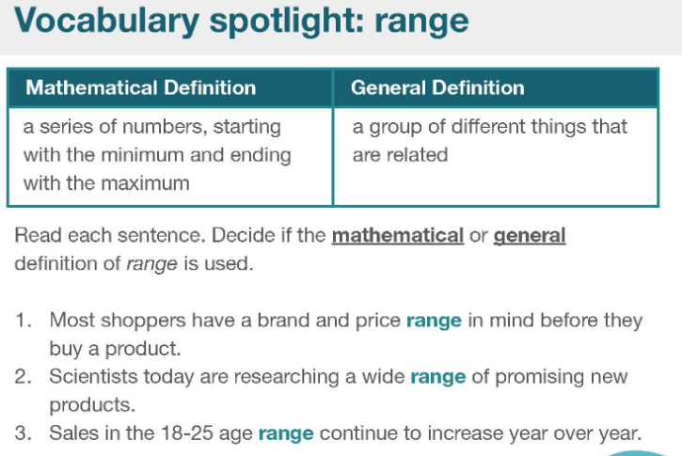

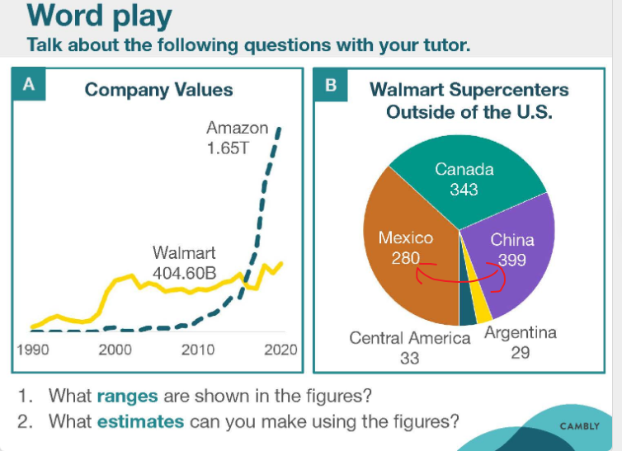



|  |  |  |
| --- | --- | --- |
| Surpass  Overcome  Exceed  More than  Greater, bigger | /səˈpɑːs/  Surpass the advanced | be or do something to a greater degree  **her performance surpasses that of any other student I know** |
| Air conditioner |  |  |

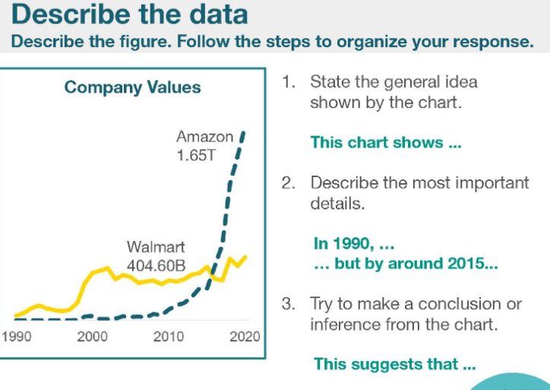

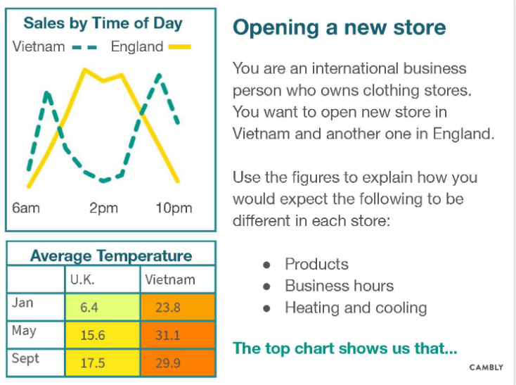

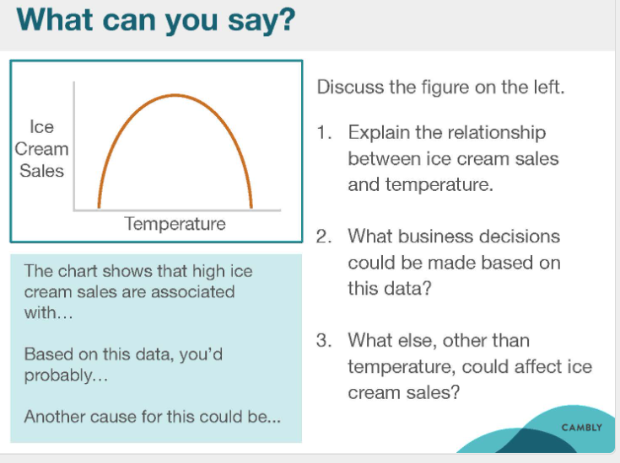

|  |  |  |
| --- | --- | --- |
| Between  middle |  |  |
| The relationship between ice cream sales and temperature |  |  |

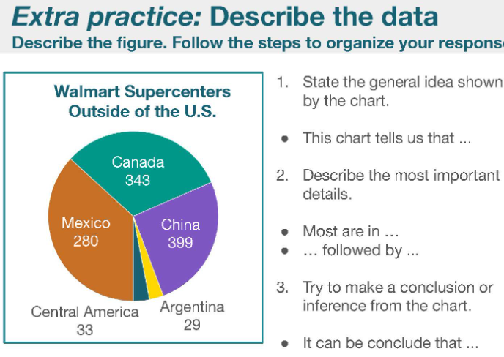

From different viewpoint, we get the different concluding.

From the graph, we get directly get the occupy of **

From the population, we know the biggest consumer market is China